



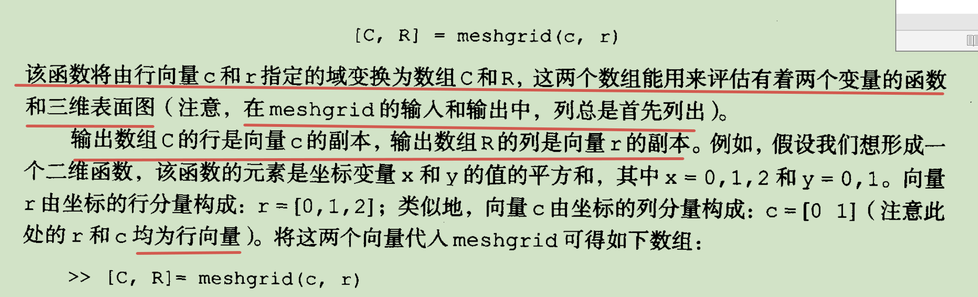

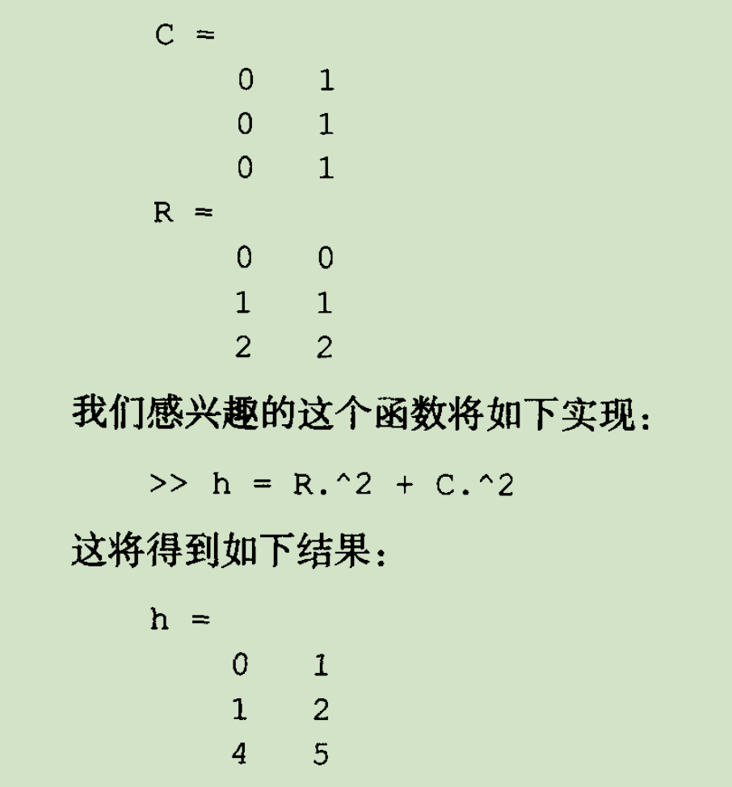



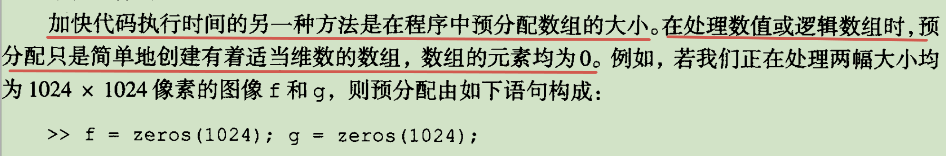

function [rt,f,g] = twodsin(A, u0, v0, M,N)

% The comparison is based on implementing the function

% f(x,y) = Asin(u0x+v0y) for x = 0,1,2,..M-1 and

% y = 0,1,2,...N-1. The inputs to the funcion are

% M and N and the constants in the function.

% First implement using for loops

tic %start timing

for r = 1:M

u0x = u0\*(r-1);

for c = 1:N

v0y = v0\*(c-1);

f(r,c) = A\*sin(u0x + v0y);

end

end

t1 = toc; %End timing

% Now implement using vectorization

tic %start timing

r = 0:M-1;

c = 0:N-1;

[C,R] = meshgrid(c,r);

g = A\*sin(u0\*R + v0\*C);

t2 = toc; %End timing

%Compute the ration of the two times

rt = t1/(t2+eps); % use eps in case t2 is close to zero

f = mat2gray(f);

imshow(f);

g = mat2gray(g);

imshow(g);

